# Additional Question

The management wants a small standalone application to find out and visualize the correlation, if any, between the age and salary of all their staff who are on an hourly wage. This information is important to the Human Resource department in order for them make sure that staff salaries are competitive with industry wages and are not discriminatory.

1. Extract the date of birth and salary information from marathon-skills-2015-staff-import.xls into a CSV (Comma Separated Variable) file with unnecessary data filtered out. **NOTE:** Do not perform any calculations in Excel.
2. Plot a graph (500 x 500px) where the vertical axis (y-axis) represents the age and the horizontal axis (x-axis) the salary. The point of origin of both axes is from 0 (zero).
3. Add the labels to both axes as exactly shown in the wireframe.
4. Using simple linear regression analysis, plot the data points on the said graph.
5. Plot a regression line based on the data. You will need to use formula (4).
6. Display the regression equation on the graph in the form shown in formula (3) near the middle of the horizontal axis.
7. Provide a slider control to allow the user to choose the number of data points to display. (30-200). The graph should redraw the data points and recalculate the regression equation as the slider is moved.

Use the formulas below to find the regression equation which will be used to calculate the predicted horizontal-axis values:

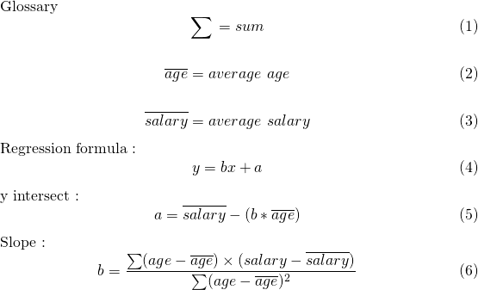

# Wireframe

